**CRAFT CREATOR**

**HIRING MANAGEMENT SYSTEM**

**Submitted for**

**SOLVING PROBLEMS WITH DESIGN THINKING & INNOVATION**

Submitted by:

**E22BCAU0055 RIYA GUPTA**

**E22BCAU0028 VINAY BHANDARI**

**E22BCAU0022 VANSH KOHLI**

**E22BCAU0012 VAIBHAV KANSAL**

**E22BCAU0017 HARNOOR SINGH**

Submitted to

**DR. SANJAY GUPTA SIR**

**APRIL-23**

**SCHOOL OF COMPUTER SCIENCE AND ENGINEERING**

**INDEX**

|  |  |
| --- | --- |
| S.NO | TOPICS DISCUSS |
| 1. | ABSTRACT |
| 2. | INTRODUCTION |
| 3. | RELATED WORK |
| 4. | METHODOLOGY |
| 5. | RESULTS |
| 6. | USE-CASE DIAGRAM |
| 7. | & CONCLUSION |

1. **ABSTRACT:**

Over the past two decades, craft has had an extraordinary resurgence, leading to a broader transformation of business sectors. Craftwork focuses on human labour, contrasting with mechanized processes leading to globalization and standardization. However, the existing literature on craft is scant and fragmented. Therefore, we need to have a nuanced understanding and consensus on how organization and management scholars have expended effort to contextualize craft across multiple disciplines and paradigms. To address this research gap, we reviewed 153 articles to identify various underlying themes of the existing literature on crafts and craft approaches to work. Specifically, this paper makes three broad contributions from the perspective of society and policy makers. First, we provide a critical account of perspectives on crafts. Second, we offer an organizing framework regarding views, enabling conditions, drivers, and outcomes. Third, this paper identifies opportunities and fruitful areas for scholars to engage in future research to explore craft-based approaches to work in various formal and informal settings. Lastly, this article paves pathways to build and sustain crafts as a humanized form of employment in present-day society – as an alternative to corporate-driven large-scale industrial approaches.

1. **Introduction:**

The craft production definition is the manufacturing process of making products, one by one, with or without the aid of tools, usually in a job shop manufacturing setting. Craft production was the most common method of manufacturing pre-industrialization, such as when making pottery by hand.

Craft Creator is a cutting-edge digital platform that brings together fans and craft makers in a seamless manner. It embodies the principles of user-centered design, providing a rewarding experience for all parties involved. In the field of artisanal crafting, Craft Creator establishes a new benchmark thanks to its strong capabilities and user-friendly interface.

By offering both clients and craftsmen personalized profiles, it increases user engagement. By interacting with clients, sharing experiences, and showcasing their portfolios, artisans can promote authenticity and a sense of community. Conversely, customers have the ability to go through artisan profiles, see earlier creations, and get in touch with their preferred artists.

THE PROJECT CAN NOT PATENTED as The first piece of the puzzle that needs to fit is the fact that not all craft ideas can be trademarked. A few requirements must be met for your craft idea to qualify for a patent: it must be novel (meaning no one else has thought of it before), useful (having a real-world use), and non-obvious (not just a straightforward alteration of something that already exists). You may be wondering if your craft idea can even be trademarked if it's a decorative pattern for ceramics. Its uniqueness and practicality provide the answer. As an e-commerce website are products are not always patent able as the designs might be similar to a patent table item present in the market. Most of a product are handcrafted with unique sense in mind but at the same time it could be already patent previously so every design on paper is important to keep and necessary for analysis of patentable and non patentable items in our collection of Products.

Estimating the project cost for developing and operating a craft creator hiring and management website requires a comprehensive analysis of various factors. Here's a breakdown of potential expenses over three years:

1. Development Costs:

- Labor: Hiring developers, designers, and project managers. Estimated cost: INR 20,00,000 to INR 10,00,00 per year.

- Software: Licensing fees for development tools, platforms, and software. Estimated cost: INR 5,00,000 to INR 8,00,000 per year.

- Hardware: Servers, computers, and other necessary equipment. Estimated cost: INR 3,00,000 to INR 5,00,000 initially.

- Services: Outsourcing certain development tasks or consulting services. Estimated cost: INR 1,00,000 to INR 3,00,000 per year.

2. Operational Costs:

- Marketing: Promotional campaigns, advertising, and brand building. Estimated cost: INR 1,00,000 to INR 5,00,000 per year.

- Maintenance: Regular updates, bug fixes, and server maintenance. Estimated cost: INR 5,00,000 year.

- Customer Support: Hiring support staff and implementing helpdesk systems. Estimated cost: INR 5,00,000 per year.

- Utilities: Internet, electricity, and office rent (if applicable). Estimated cost: INR 8,00,000 to INR 12,00,000 per year.

3. Miscellaneous Costs:

- Legal and Regulatory Compliance: Hiring legal counsel, obtaining licenses, and complying with regulations. Estimated cost: INR 3,00,000 to INR 5,00,000 initially and INR 2,00,000 to INR 4,00,000 per year.

- Contingency: Setting aside funds for unforeseen expenses or delays. Estimated cost: INR 5,00,000 initially and INR 3,00,000 to INR 5,00,000 per year.

4. Total Estimated Cost Over Three Years:

- Development: INR 65,00,000 to INR 95,00,000

- Operational: INR 51,00,000 to INR 82,00,000

- Miscellaneous: INR 13,00,000 to INR 24,00,000

5. Grand Total:

INR 98,00,000 to INR 1,00,00,000

This estimation provides a rough overview, and actual costs may vary based on factors like market conditions, technology advancements, and business strategies. Regular monitoring and adjustments to the budget will be essential to ensure the project's success within the allocated resources.

The process of estimating the project cost for creating and managing a recruiting and management website for craft creators requires a detailed examination of several costs over a period of three years. The process of development first necessitates large outlays for hardware, software licenses, labor expenditures for recruiting developers, designers, and project managers, as well as outsourcing services for specialized work. Operational costs include recurring expenditures for things like utilities, maintenance, marketing initiatives, and customer service. It's also critical to budget for licensing, legal compliance, and contingencies. A thorough estimate recommends a three-year total investment of between INR 98,00,000 and INR 1,00,00,000, subject to change depending on market conditions and tactical choices. Maintaining the project's viability and success requires constant budget monitoring and modifications.

1. **Related Work :**
2. **Ethical:**

By openly displaying artisans' work and establishing reasonable prices, our platform guarantees that they are fairly compensated. Respecting local customs, encouraging sustainable practices, and procuring materials ethically are our top priorities. Our dedication include cultivating enduring connections with craftspeople, advocating for their welfare, and conserving customary artistry.

1. **Legal/Privacy:**

We follow stringent privacy guidelines in accordance with GDPR and other pertinent laws. Your personal data is protected and used only to fulfill orders, handle deliveries, and provide customer service. We protect your privacy and security by never selling or sharing your data with outside parties without your express permission.

1. **Terms & Conditions:**

You accept our terms and conditions by using our platform to interact with us and make purchases. Among them is our return policy, which permits returns under some restrictions within a predetermined time frame. Because they are handmade, please be aware that there may be some variances. Prices, terms, and policies are subject to change at any time. Users will be promptly informed of any changes.

1. **Feasibility Study:**

Market Demand: Increasing demand for artisanal craftsmanship and handcrafted goods in online mode is rare . - Technical Feasibility: The success of online marketplaces is demonstrated by existing platforms. - Resource Availability: Having access to knowledgeable designers, developers, and marketers helps business personality. - Financial Viability: Platform development and marketing demand a one-time investment. The business context involves targeting craftsmen and craft creators who are looking for opportunities. - Competition Analysis: Determining the advantages and disadvantages of current platforms. - Value Proposition: Providing artisans with an easy-to-use platform to exhibit their work and establish connections with prospective customers. Revenue Generation: - Commission Model: Assessing a percentage fee on sales made by artists to customers. - Premium Features: Providing craftspeople with marketing tools or increased visibility through premium features. - Subscription Services: Offering craft artists subscription packages with extra perks.The analysis of opportunities shows that there is a growing demand for handmade and distinctive products. - Global Reach: Making use of the internet to link artists with customers anywhere in the world. - Social Impact: Providing support to local economies, empowering craftspeople, and maintaining traditional workmanship. Scalability: The ability to broaden the scope of services beyond handcrafted goods to encompass other artistic disciplines.

1. **Methodology:**

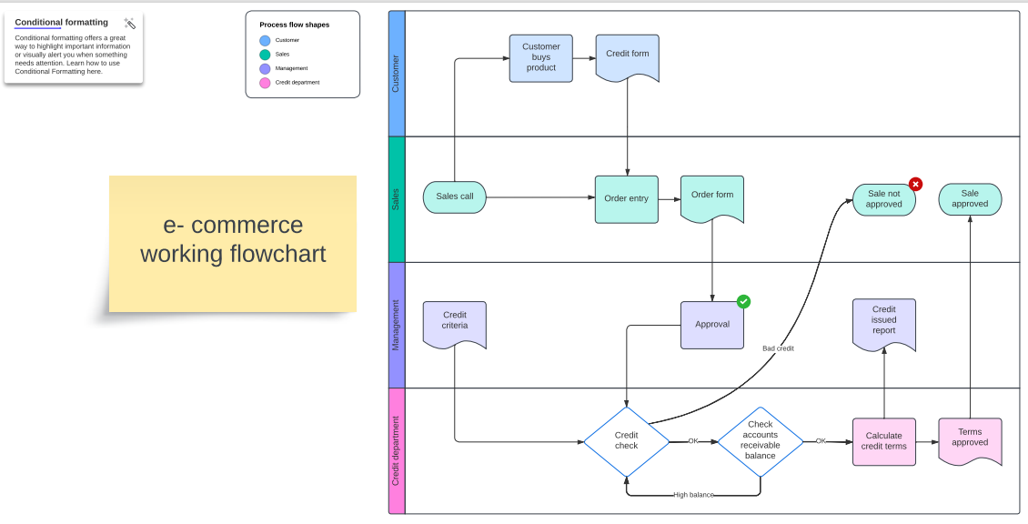

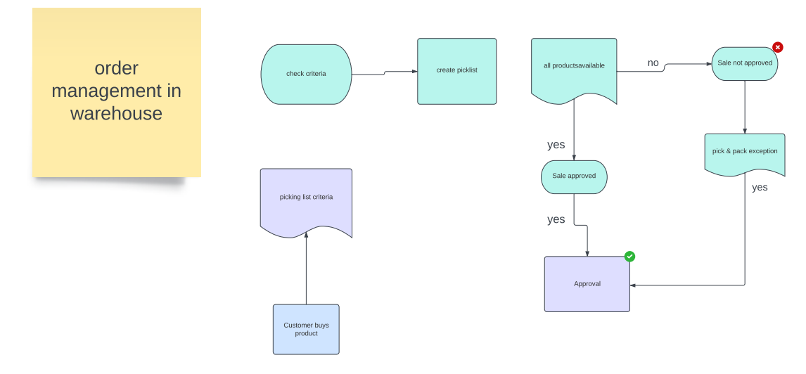

**This customized approach improves openness and trust, which benefits the user experience as a whole:**

1. **User-Centered Interface:**

Craft Creator user interface is a prime example of user-centric design, which places a premium on accessibility and usability. Users are immediately drawn into the world of handmade creations by the homepage's lively graphics and simple navigation. Users are guided to important features, such perusing crafts, sharing projects, and interacting with craftsmen, by prominent call-to-action buttons. Whether using a desktop or mobile device, the UI is responsive and guarantees a smooth experience.

Craft Creator Website includes elusive features like:

1.Call Action Buttons

2.Individual Product Page

3.product catalog

4.Add to Cart function

5.Profile Icon

6.Helpful Directing links

7.Slider Function

1. **Experimental Result and Discussion:**

Craft Creator Hiring Management System and Website has demonstrated notable success in facilitating connections between craft creators and employers and customers.

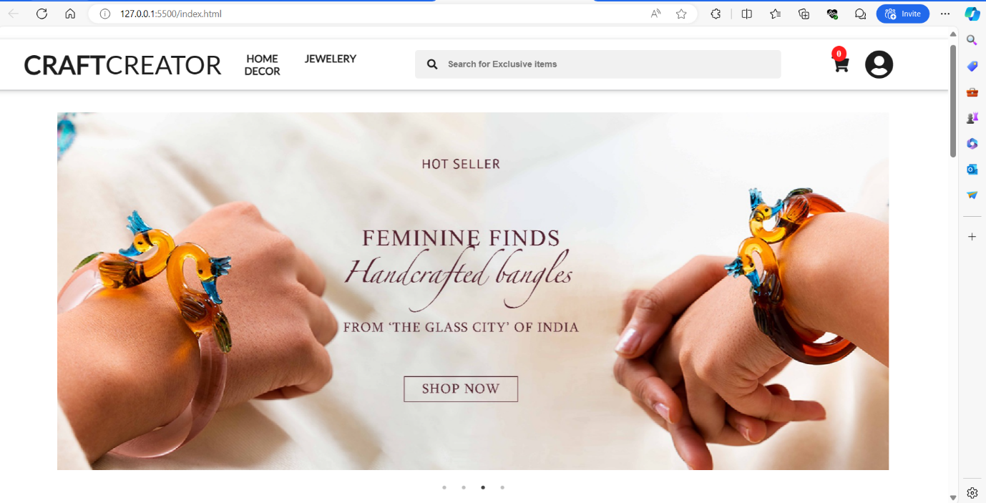

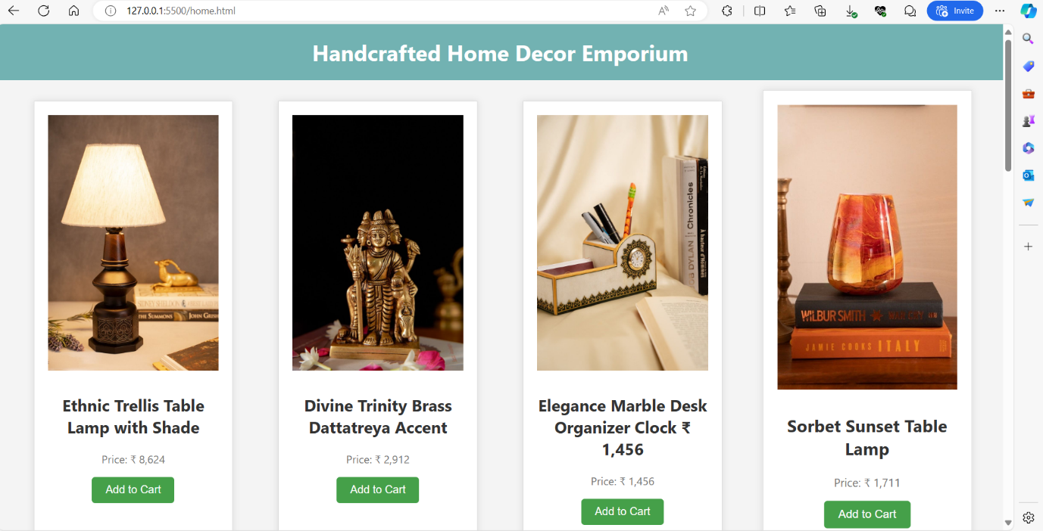

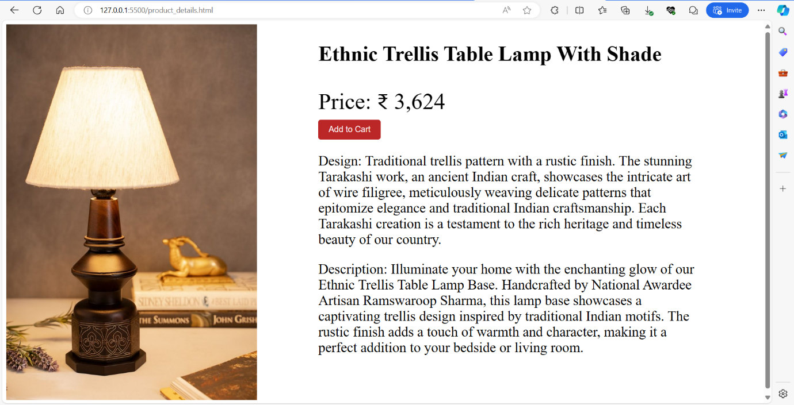

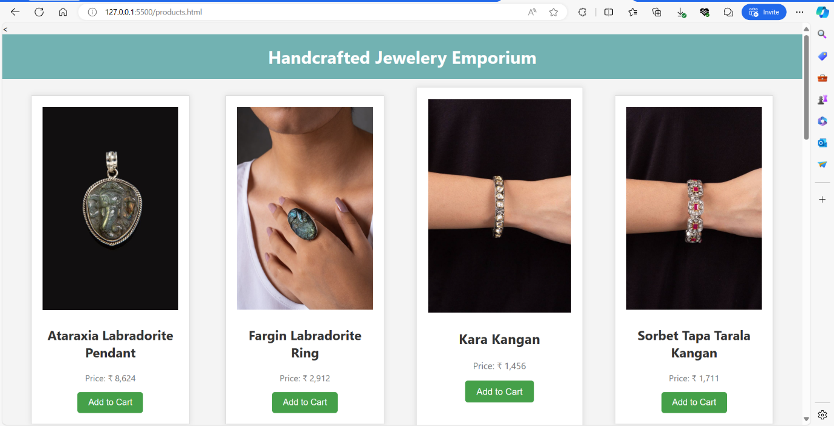

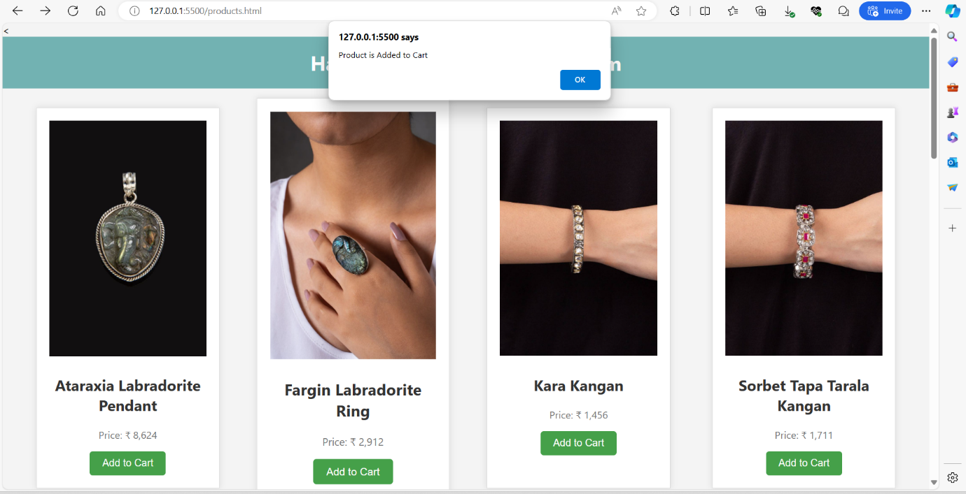

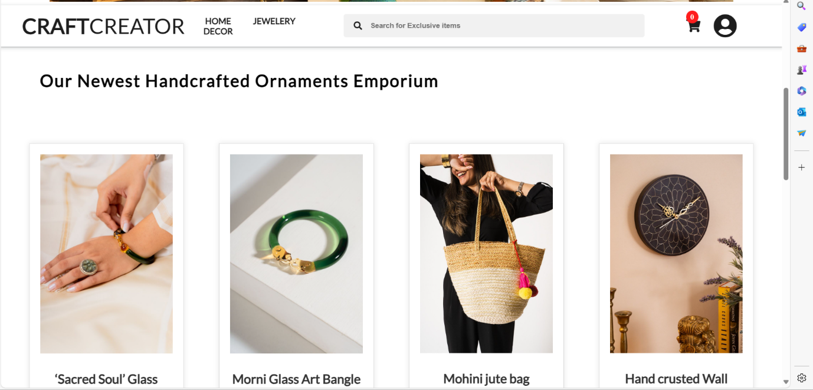

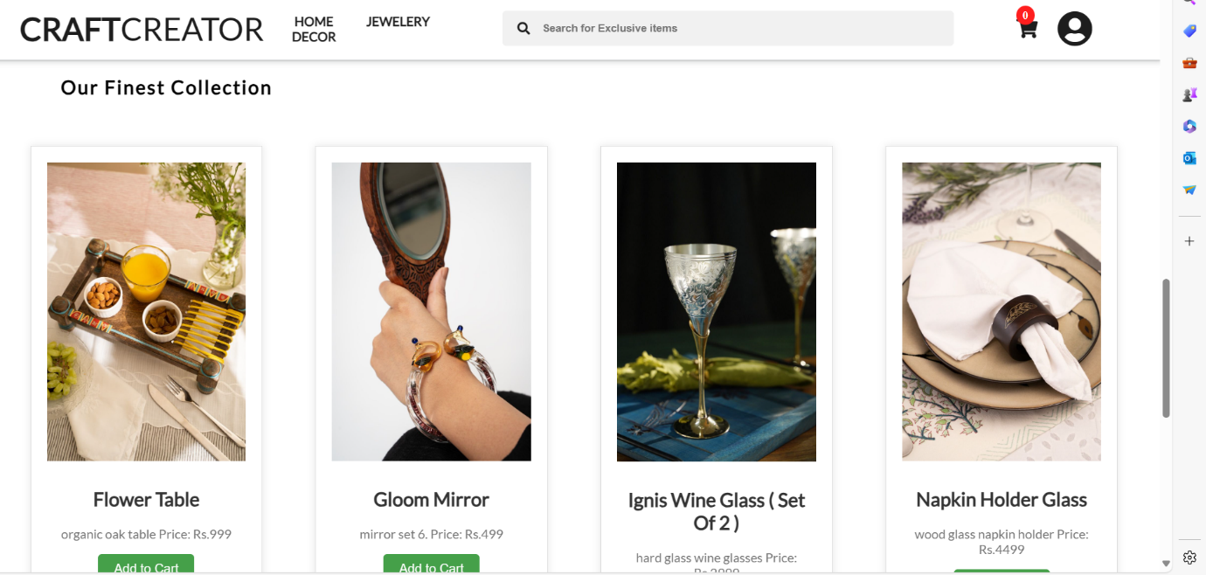

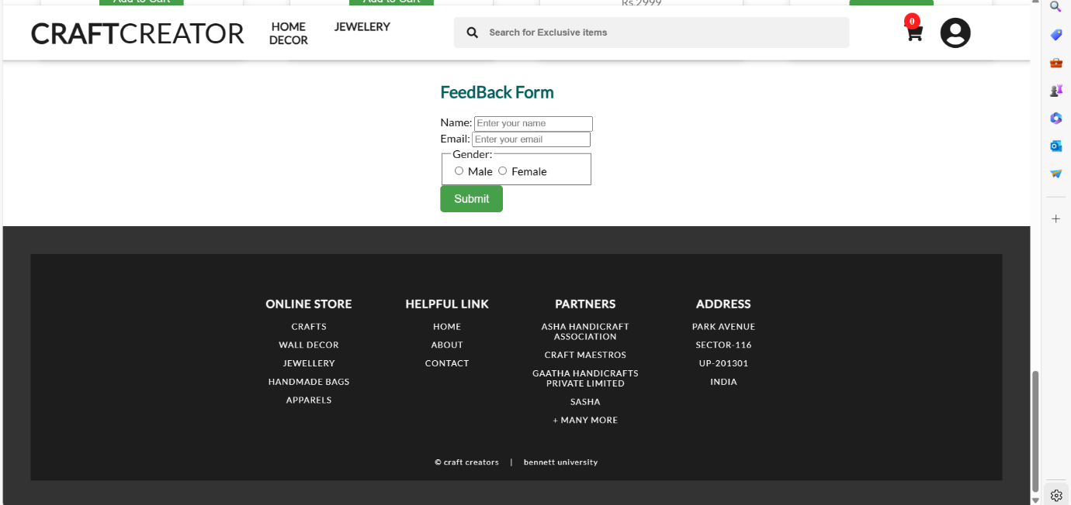

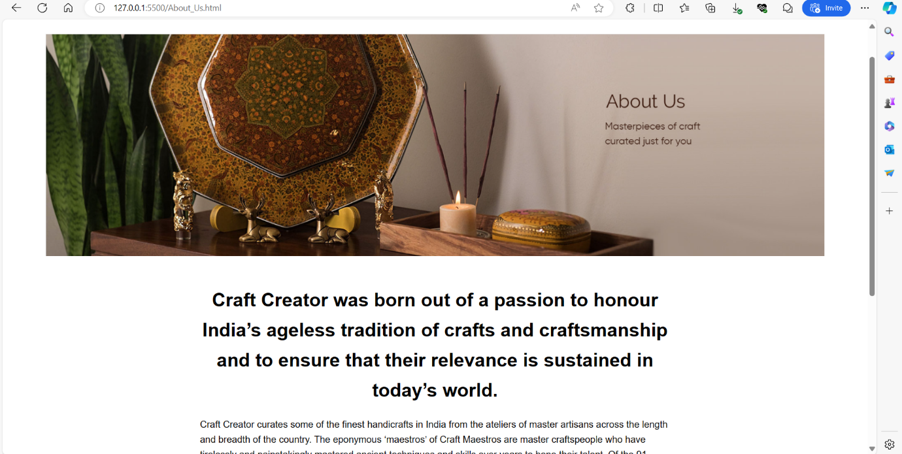

1. **USE CASE DAIGRAM FOR E-COMMERCE WEBSITE:**

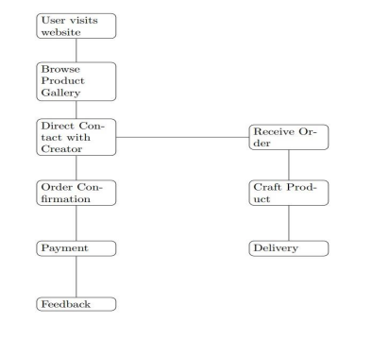

**7. Conclusion:`**

We have designed a creative and responsive website which includes hand crafted goods ultimately helping the poor craft makers and freelancers.

Craft Creator Hiring Management System offers a comprehensive solution for streamlining the hiring process for craft creators. Its features encompass everything from job posting and applicant tracking to assessment and onboarding. By utilizing this system, companies can efficiently manage their recruitment pipeline, ensuring that they find the best talent for their creative projects. The system's automation capabilities reduce manual tasks, saving time and resources for HR professionals. With its user-friendly interface and customizable options, Craft Creator Hiring Management System empowers organizations to build strong teams and foster innovation in their craft-based endeavors.

**LINK OF BLOG ON MEDIUM.COM-**

<https://medium.com/@riyagupta8076/crafting-connections-the-emergence-of-craft-creator-websites-3acdb516b484>

**LINKED IN POST:**

<https://www.linkedin.com/pulse/empowering-artisans-rise-craft-creator-website-riya-gupta-llqfc>

**GITHUB LINK:**

<https://github.com/riyag8076/CRAFT-CREATORHIRING-AND-MANAGEMENT-WEBSITE>